Quaid I Azam University Islamabad



Recipe Management System

(Case study # 02)

**Assignment # 01 (Software Construction “Cs-322 SC”)**

**Instructor:**

* Mam Onaiza Maqbool

**Team Members-Group 03:**

* Shayan Danish 04072212006 (Team Lead)
* Syed Muhammad Saqlain 04072212036
* Fatah Ali Khan 04072113010

Table of Contents

**1.** **Introduction:** 3

**2.** **Use case Diagram:** 4

**3.** **Use Case Descriptions:** 5

# **Introduction**

Our project aims to develop a user-friendly web system for managing recipes, ingredients, and sales data. The system will allow users to create, edit, and delete recipes, while also providing functionality to manage ingredient inventory. Key features include calculating total quantity and cost based on recipe ingredients and tracking sales information. Through intuitive design and essential functionalities, our system will streamline operations for businesses in the culinary industry, enhancing efficiency and profitability.

# **2. Use case Diagram:**

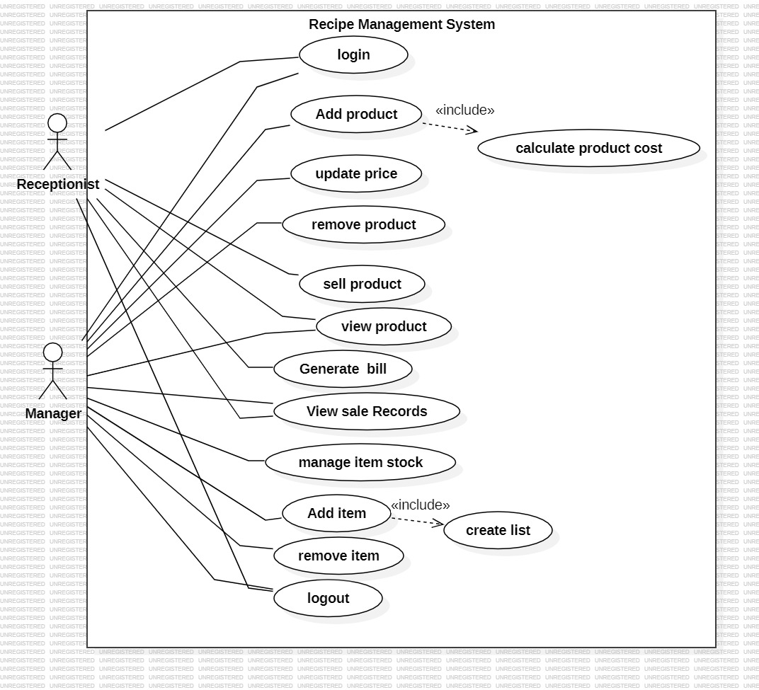

# **3. Use Case Descriptions:**

**By: Shayan Danish**

**Use case name**: Add item

**Primary actor**: Manager

**Pre-condition:**

* Manager is authenticated and authorize to add item in the system.

**Post condition**:

* Manager have access and has successfully added the item in the system.

**Main success scenario:**

1. Manager create list of item. System provide list to add items.
2. Manager add item and the system added them in the list.
3. Manager select item, system save the selected item in the list.
4. Manager add quantity. System save the quantity in the list.
5. Manager save the record

**Alternate flow:**

1. If the List is not created. System give response in the form of message to user to create again.
2. Item is not available. If the item is not available then system send message to add valid item in the system.
3. Item selection is not correctly. The system will guide user to reselect item again.
4. Manager enter string for the quantity instead of numeric value then the system show message for valid input.
5. System failure.

**Technology and Data Variation List:**

* The system must ensure secure storage and retrieval of item data.
* The data structure for item information, including attributes such as name, quantity, and ingredients, according to data model.

**Frequency:**

Manager will add item daily according to their need.

**Special Issues:**

* Compliance with relevant data protection and privacy regulations is essential.

**BY:** Syed Muhammad Saqlain (0407221236)

**Use case Name:** Sell Product

**Primary Actor:** Receptionist.

**Pre-conditions:**

Receptionist authenticated to sell product.

**Post-conditions:**

A receptionist can login and a product will be sell.

**Main Success Scenario (Basic Flow):**

1. Receptionist selects the product and system add the product to sell.
2. Receptionist select the quantities and system update the quantities.
3. Receptionist confirm the order and system will save the order.

**Extensions (Alternate Flows):**

1. Product is not available and system will notify to add the product first.
2. Quantity is in negative integer so system will notify that quantity cannot be negative.
3. Confirmation failed due to system failure. System notify to contact with admin to fix it.

**Special Requirements:**

The system should support the efficient selling system.

**Technology and Data Variation List:**

The special database is required to save sell records.

**Frequency:**

The frequency of this use case depends on the number of costumer per day. Many times a day.

**Special Issues:**

Handling of multiple order at same time can inter mix data.

**BY:** Fatah Ali khan

**Use Case:** ADD PRODUCT

**Primary Actor:** Manager

**Pre-Condition:** The user is authenticated and authorized to add product and its details.

**Post Condition**: The product is added into the system successfully.

**MAIN SUCCESS SCENARIO:**

1. Manager enters the name of product into the system.

2. System saves the name of product.

3. Manager enters the recipe of product with its quantities.

4. System saves the recipe details.

5. System calculate the cost of product according to the quantities of items.

6. Manager fix the product cost.

7. System saves the cost and adds into the product list.

**Extensions (Alternate Flows):**

1. If the manager enter numbers, notify to enter name in alphabet letters.

2. System shows error.

3. If manager enters the recipe of product without its quantity, the system shows error and notify to add quantity.

4. If there is any error in recipe then system cannot save it , it shows error.

5. If the product quantity is not given in the list then system notify to enter the quantity.

6. If manager add product cost in negative then system shows error.

7. If system crash then it cannot calculates.

**Frequency:**

Manager will add product daily at any time. Many times a day.